

**DEVELOPMENT OF A WEB-BASED STUDENT ACADEMIC ADVISING SYSTEM**

**BY**

**AHMED MUHAMMED**

**PSC/2019/11206**

**DEPARTMENT OF COMPUTER SCIENCE AND INFORMATION TECHNOLOGY**

**FACULTY OF COMPUTING, FEDERAL UNIVERSITY DUTSIN-MA, NIGERIA.**

**OCTOBER 2023.**

**DEVELOPMENT OF A WEB BASED STUDENT ACADEMIC ADVISING SYSTEM**

**BY**

**AHMED MUHAMMED**

**PSC/2019/11206**

**A PROJECT SUBMITTED TO THE DEPARTMENT OF COMPUTER SCIENCE AND INFORMATION TECHNOLOGY, FACULTY OF COMPUTING, FEDERAL UNIVERSITY DUTSIN-MA, NIGERIA, IN PARTIAL FULFILLMENT OF THE REQUIREMENTS FOR THE AWARD OF THE DEGREE OF BACHELOR OF SCIENCE [B.SC (HONS)] IN COMPUTER SCIENCE AND INFORMATION TECHNOLOGY.**

**OCTOBER 2023.**

# DECLARATION

I, **Ahmed Muhammed**, declare that this project titled “**DEVELOPMENT OF A WEB-BASED STUDENT ACADEMIC ADVISING SYSTEM**” has been carried out by me under the supervision of **Mrs. Faith O. Echobu** in the Department of Computer Science and Information Technology, Faculty of Computing, Federal University, Dutsin-Ma.

AHMED MUHAMMED ………………………………………

PSC/2019/11206 Signature & Date

# CERTIFICATION

We certify that this work was carried out by AHMED MUHAMMED in the Department of Computer Science and Information Technology, and meets the regulation governing award of the Degree of Bachelor of Science of the Federal University, Dutsin-Ma and it is approved for its contribution to scientific knowledge and literacy presentation.

**Mrs. Faith O. Echobu**

(Project Supervisor) Signature and Date

Dr. Zahradden Sani

(Head of Department) Signature and Date

Prof. A. A. Obiniyi

(External Examiner) Signature and Date

# ACKNOWLEDGEMENT

First and foremost, I must express my profound gratitude to Almighty God for his provision and wisdom that guided me throughout the period of this project. A work of this nature cannot done successfully without the help, goodwill, co-operation and moral assistance of others.

I therefore say a big thanks to my supervisor Mrs. Faith O. Echobu, who was to take time out of her busy schedule to supervise me during the project and gave me quality input that has further enhanced the quality of this work.

This will not be complete without specially acknowledging my beloved parents, Mr. Abdulwasiu Muhammed and Mrs. Dupe Bashirat Muhammed, and my siblings, my uncles, my aunties for their support for me in all human endeavours. They sponsored me from childhood till date. I am also grateful for my friends, both home and abroad who contributed in different ways to my success, may God bless you all.

**Table of Contents**

DECLARATION iii

CERTIFICATION iv

ACKNOWLEDGEMENT v

LIST OF FIGURES viii

LIST OF TABLES ix

ABSTRACT x

CHAPTER ONE 1

INTRODUCTION 1

1.1 Background to the Study 1

1.2 Statement of the Problem 2

1.3 Aim and Objectives 3

1.4 Scope and Limitations of the Study 4

Limitations of the Study: 4

1.5 Significance of Study 5

1.6 Definition of Terms 6

1.0 Chapter Summary 8

CHAPTER TWO 10

LITERATURE REVIEW 10

2.1 Introduction 10

2.2 Review of Related Work 11

2.3 Proposed System Design 13

2.4 Theory of the Study 15

2.5 Chapter Summary 16

CHAPTER THREE 17

METHODOLOGY 17

3.0 Introduction 17

3.1 Rational Unified Process (Rup) Model. 17

3.2 Challenges of the Rational Unified Process (Rup) Model. 18

3.3 Why Rational Unified Process (Rup) Model. 18

3.4 The Rational Unified Process Model Phases 19

3.5 Inception Phase 19

3.6 Elaboration Phase 21

3.6.1. Requirement Analysis 21

3.6.2 Software Requirements 21

3.6.3 Hardware Requirements 23

3.6.4 Application Requirements 24

3.7 Construction Phase 25

3.7.1 Data Flow 25

3.7.2 System Logical ER Design 28

3.8 Transition Phase 28

3.9 Chapter Summary 29

CHAPTER FOUR 30

IMPLEMENTATION 30

4.0 Introduction 30

4.1 Deployment Using Xampp Server 30

4.2 Home Page 30

4.3 Database 31

4.4 Admin Login Page 32

4.5 Admin Dashboard 32

4.6 Student Registrations/ Login 33

4.7 Student Dashboard 34

4.8 Testing And Results 35

4.9 Chapter Summary 36

CHAPTER FIVE 37

SUMMARY, CONCLUSION, AND RECOMMENDATIONS 37

5.0 Summary 37

5.1 Conclusion 37

5.2 Recommendation 37

REFERENCE 39

APPENDIX 42

# LIST OF FIGURES

Fig 1: System architecture diagram…………………………...……………………..26

Fig 2: DFD Level 0…………………..……………………………………………....28

Fig 3: DFD Level 1 Figure 4: DFD Level 2…………………………………………28

Fig 5: ER Diagram……………………………………………………..…………….29

Fig 6: RUP model………………………………………………………………...….30

Fig 4.1: Home Page Student academic advising………………………………...…..32

Fig 4.2: Student academic advising database table………………………………….33

Fig 4.3: Admin login page…………………………………………………...............33

Fig 4.4: Admin Dashboard…………………………………………………..............34

Fig 4.5: Student login page…………………………………………………………..35

Fig 4.6: Student Registration Form page…………………………………………….35

Fig 4.7: Student Dashboard………………………………………………………….36

# LIST OF TABLES

Table 1: System Evaluation Rating of the System Quality………………………....36

Table 2: System Evaluation Rating of the System Use……………………………..37

# ABSTRACT

*This project presents a comprehensive proposal for the creation of a Student Academic Advising System at Federal University Dutsin-Ma, Katsina State. The primary goal of this system is to enhance the academic advising process through the integration of various technologies, including HTML, CSS, JavaScript, PHP, and MySQL. The project will follow the Rational Unified Process Model to ensure a structured and efficient development process. The Student Academic Advising System will offer several key features, including streamlined course planning, improved communication channels between students and advisors, and personalized academic guidance. It will be comprised of distinct modules for student profile management, course selection and planning, advisor interaction, and administrative tools. To facilitate its implementation, the system will be deployed locally on XAMPP. By doing so, we anticipate significant benefits, such as heightened student satisfaction, improved retention rates, the promotion of a collaborative academic atmosphere, and a reduction in administrative workload, ultimately leading to more efficient resource utilization.*

# CHAPTER ONE

# INTRODUCTION

## 1.1 Background to the Study

In the contemporary education landscape, academic advising plays a crucial role in guiding and supporting students throughout their educational journey. Effective academic advising systems provide students with valuable insights, personalized guidance, and timely support to help them make informed decisions regarding their academic pursuits. Traditionally, academic advising has been conducted through face-to-face interactions between students and advisors. However, with the rapid advancements in technology and the growing reliance on digital platforms, there is a need to develop more efficient and accessible systems that leverage the potential of the web (Kitsantas, Dabbagh, 2016).

The advent of web-based technologies has revolutionized various sectors, and education is no exception. Web-based systems offer numerous advantages such as accessibility, flexibility, and scalability. They have the potential to enhance the academic advising process by providing students with anytime, anywhere access to valuable resources, advice, and support. Moreover, web-based systems can streamline administrative tasks, improve communication between advisors and students, and facilitate the exchange of information in a more efficient and organized manner (Alvarez, and Toledo, 2018).

The current methods of academic advising often suffer from limitations such as time constraints, scheduling conflicts, and a lack of centralized information. Students may face difficulties in finding the necessary resources or scheduling appointments with advisors, leading to delays and potential academic setbacks. These challenges underscore the need for a comprehensive and user-friendly web-based student academic advising system. (Rodríguez-García, Favela, & Herrera-Alcántara, 2019).

The development of a web-based student academic advising system aims to address these limitations and provide a technologically advanced platform that enhances the overall academic advising experience. By leveraging web-based technologies, this system will enable students to access a wide range of advising resources, including course catalogs, academic requirements, degree plans, and other relevant information. Additionally, it will facilitate online appointment scheduling, allowing students to book appointments with their advisors at their convenience (Mallory, 2016).

The web-based student academic advising system will also incorporate features that promote effective communication and collaboration between students and advisors. It may include real-time chat functionalities, discussion forums, and document sharing capabilities, enabling advisors to provide personalized guidance and support to students efficiently. Furthermore, the system can utilize data analytics to generate personalized recommendations and proactive alerts, helping students stay on track with their academic goals and making timely interventions when necessary (Zhou, Liu, and Chen, 2020).

Overall, the development of a web-based student academic advising system has the potential to revolutionize the traditional advising process and enhance the educational experience for students. By leveraging web technologies, this system can improve accessibility, efficiency, and effectiveness in academic advising, empowering students to make informed decisions and achieve their academic goals.

## 1.2 Statement of the Problem

Despite the importance of academic advising in supporting student success, traditional methods of advising face several challenges that can hinder students' progress and academic achievements. These challenges include:

1. Limited Accessibility: Face-to-face advising sessions often require students to visit campus during specific office hours, which can be inconvenient for those with scheduling conflicts or off-campus commitments. This limitation may result in delays in receiving timely guidance and support.
2. Lack of Centralized Information: Students may struggle to navigate through various academic resources, including course catalogs, degree requirements, and academic policies. This scattered information can lead to confusion and difficulty in making informed decisions.
3. Communication Barriers: Communication between students and advisors may be hindered by geographical distances, time differences, or conflicting schedules. As a result, students may experience delays in obtaining necessary advice or may miss important opportunities.
4. Inefficient Appointment Scheduling: Coordinating appointments with advisors can be a time-consuming process, involving phone calls or email exchanges. The lack of a streamlined and efficient scheduling system may lead to delays and scheduling conflicts (Kitsantas, and Dabbagh, 2016).
5. Limited Personalization: Traditional advising methods often lack personalized guidance tailored to individual students' needs, interests, and goals. This can result in a one-size-fits-all approach that may not adequately address specific academic challenges and aspirations (Park and Yun, 2019).

To address these issues, the development of a web-based student academic advising system is necessary. This system will aim to overcome the limitations of traditional advising methods by providing a comprehensive, accessible, and personalized platform for students to receive academic guidance and support. By leveraging web technologies, the system will enable students to access information, schedule appointments, communicate with advisors, and receive personalized recommendations, thereby enhancing the overall academic advising experience and improving student success rates (Mays, 2018).

## 1.3 Aim and Objectives

The aim of the study is to develop a web-based student academic advising system which will enable students to communicate directly with their advisers and receive prompt response to their queries which will overcome the inherent challenge with traditional advising methods.

The objectives are to:

1. Investigate and assess the current student advising system.
2. Create a user-friendly application utilizing PHP and MySQL.
3. Evaluate and enhance the performance of the application.

## 1.4 Scope and Limitations of the Study

**Scope of the Study:**

The scope of this study focuses on the development and implementation of a web-based student academic advising system. It encompasses the design, development, and evaluation of the system's features and functionalities. The study will primarily target students and academic advisors in an educational institution or university setting (Liu, and Qiu, 2019).

The web-based student academic advising system will aim to provide students with access to advising resources, appointment scheduling capabilities, communication tools, and personalized recommendations. It will cover areas such as course catalogs, academic requirements, degree plans, and academic policies. The system may also incorporate data analytics techniques to analyze student data and generate personalized recommendations (Kitsantas and Dabbagh, 2016).

The study will involve the design and development of a user-friendly interface, the implementation of the system's features, and the evaluation of its effectiveness. It may also include gathering feedback from students and advisors to assess user satisfaction and identify areas for improvement. (Kitsantas and Dabbagh, 2016).

### Limitations of the Study:

While this study aims to contribute to the advancement of academic advising systems, there are certain limitations to consider:

1. Generalizability: The findings and conclusions of this study may be specific to the context of the educational institution or university where the system is implemented. The effectiveness of the system may vary in different institutional settings.
2. Technical Constraints: The development of the web-based student academic advising system may be subject to technical constraints such as time, resources, and expertise. The system's functionalities and features may be limited by the available technology or infrastructure.
3. User Adoption: The success of the system depends on user adoption and acceptance. The study does not guarantee widespread adoption of the system by all students and advisors, and the level of engagement and usage may vary among individuals. (Alvarez and Toledo, 2018).
4. Privacy and Security: The study acknowledges the importance of privacy and security in handling student data. However, it may not address all potential privacy concerns and security vulnerabilities. Implementers of the system should ensure compliance with relevant data protection regulations and implement appropriate security measures.
5. External Factors: The study does not account for external factors that may impact the effectiveness of the system, such as changes in academic policies, organizational constraints, or external technological advancements.

These limitations should be considered when interpreting the results of the study and implementing the web-based student academic advising system in real-world educational settings (Gao and Hu, 2019).

## 1.5 Significance of Study

The development of a web-based student academic advising system holds significant importance for various stakeholders in the education sector. The study's findings and the resulting system can have several benefits, including:

1. Improved Student Experience: The web-based system enhances the student experience by providing easy access to advising resources, personalized recommendations, and efficient communication with advisors.
2. Enhanced Advisor Efficiency: The system streamlines administrative tasks, enabling advisors to focus on personalized guidance and support for students, thereby increasing advisor efficiency and effectiveness.
3. Increased Student Retention and Success: The system contributes to improved student retention and success rates by providing timely support, personalized recommendations, and helping students stay on track with their academic progress.
4. Accessible and Equitable Advising: The web-based system ensures accessibility for all students, regardless of their location or scheduling constraints, promoting equal opportunities for accessing advising services and resources (Chen, Zhang, Chen, and Huang, 2018).
5. Efficient Resource Management: The system centralizes advising resources, automates appointment scheduling, and facilitates streamlined communication, optimizing resource allocation and reducing administrative burden on advisors.
6. Data-Informed Decision Making: By leveraging data analytics, the system generates insights into student performance, interests, and goals, empowering institutions to make informed decisions about curriculum planning, program improvements, and student support initiatives.
7. Future Adaptability and Scalability: The study's findings and the developed system serve as a foundation for future advancements and adaptations in academic advising, allowing institutions to expand and customize the system to meet evolving student needs and educational requirements.

Overall, the study's significance lies in its potential to transform advising processes, improve student outcomes, and enhance the overall educational experience by leveraging technology and personalized support (Liu, and Qiu, 2019).

## 1.6 Definition of Terms

**Web-based Student Academic Advising System:** A technological platform that utilizes web technologies to provide students with access to advising resources, appointment scheduling, communication tools, and personalized recommendations for academic guidance and support.

**Academic Advising:** The process of providing guidance, support, and information to students to assist them in making informed decisions regarding their academic pursuits, including course selection, program requirements, and career planning.

**User Interface:** The visual and interactive elements of a system or application that allow users to interact and navigate through the system, including menus, buttons, forms, and graphical representations.

**Accessible:** Referring to the ease with which users, including students and advisors, can obtain information, resources, or services through the web-based advising system, regardless of their physical location or time constraints.

**Personalized Recommendations:** Tailored suggestions and advice provided to students based on their individual academic performance, interests, goals, and other relevant factors, aiming to assist them in making decisions that align with their unique needs.

**Data Analytics:** The process of examining, interpreting, and deriving insights from large sets of data to identify patterns, trends, and correlations that can inform decision-making and improve system functionality.

**Appointment Scheduling:** The process of booking and managing advising appointments between students and advisors, allowing students to schedule convenient time slots to receive academic guidance and support.

**Communication Tools:** Various features and functionalities integrated into the web-based system to facilitate effective communication between students and advisors, including real-time chat, discussion forums, and document sharing capabilities.

**Centralized Information**: Consolidated and organized academic resources, including course catalogs, academic requirements, degree plans, and academic policies, made available within the web-based advising system for easy access and reference.

**User Satisfaction**: The level of contentment and positive experience reported by users, including students and advisors, in terms of the usability, effectiveness, and overall value of the web-based student academic advising system.

**Student Retention:** The ability of an educational institution to retain enrolled students until they complete their academic programs, ensuring that students persist in their studies and do not drop out prematurely.

**Academic Success:** The achievement of desired academic outcomes, including meeting academic requirements, earning satisfactory grades, and progressing towards the attainment of educational goals.

**Geographical Barriers:** Obstacles related to physical distance or location that may hinder students' access to advising services and resources, which can be overcome through the web-based system's accessibility.

**Scheduling Conflicts:** Instances where students and advisors have overlapping commitments or limited availability, leading to challenges in arranging mutually convenient advising appointments.

**Institutional Decision-making:** The process of making informed choices and policy decisions by educational institutions based on data, feedback, and insights obtained from the web-based advising system, which can influence curriculum planning, program improvements, and resource allocation.

## Chapter Summary

Chapter 1: Introduction – This chapter introduces the development of A web-based student academic advising system, highlighting its objectives and significance.

Chapter 2: Literature Review – This chapter provides a comprehensive review of existing literature on web-based student academic advising system, identifying key findings and research gaps.

Chapter 3: Methodology, Materials, and Methods – This chapter describes the methodology used for designing and implementing the system, outlining the materials, tools, and techniques employed.

Chapter 4: Implementation – This chapter focuses on the detailed implementation of the web-based student academic advising system, covering coding, database integration, and feature development.

Chapter 5: Summary, Conclusion, and Recommendation – This chapter summarizes the project’s key findings, presents conclusions, and provides recommendations for future improvements or research.

Overall, these chapters contribute to the comprehensive understanding of the design and implementation of the web-based student academic advising system. The literature review provides a foundation of existing knowledge, the methodology chapter outlines the approach taken, the implementation chapter details the development process, and the final chapter summarizes the findings and provides recommendations for future work.

# CHAPTER TWO

# LITERATURE REVIEW

## 2.1 Introduction

Academic advising plays a crucial role in supporting student success and retention in higher education institutions. To understand the current landscape and explore the potential of web-based student academic advising systems, a review of relevant literature was conducted. This literature review highlights key findings and trends in the field of academic advising and the use of technology in supporting advising practices (Chen, Zhang, Chen, and Huang, 2018).

Several studies have emphasized the importance of effective academic advising in promoting student engagement and success. They have found that personalized guidance, clear communication, and timely support significantly contribute to student satisfaction, retention, and academic achievement (Cuseo, 2017; Drake, Jordan, and Miller,2016). However, traditional advising methods face limitations in terms of accessibility, centralized information, and communication barriers, which can hinder students' progress.

Web-based student academic advising systems have emerged as potential solutions to address these challenges. Researchers have explored the benefits of such systems in enhancing the student advising experience. For example, Xu and Martin (2018) found that web-based advising systems provide students with convenient access to advising resources, streamline appointment scheduling, and facilitate effective communication between students and advisors. These features contribute to improved student satisfaction and engagement.

The use of technology, specifically web-based platforms, in academic advising has shown promise in supporting student success. Web-based advising systems have been found to increase student access to information, empower students to take ownership of their academic journey, and provide personalized recommendations (Fruhling, 2016; Street and Lang, 2017). The integration of data analytics techniques in these systems enables institutions to analyze student data, identify patterns, and provide targeted interventions and support (Ali and Hawi, 2020).

Moreover, research has emphasized the importance of user-centric design in web-based advising systems. Studies have highlighted the significance of intuitive user interfaces, ease of navigation, and user-friendly features to ensure a positive user experience (Huot, 2019; Smith and McNair, 2016). User satisfaction with the system's functionality, accessibility, and personalized support has been found to positively impact student engagement and success (Kim, 2018; Vahed, Zeinolabedini, and Aliakbari, 2019).

While web-based student academic advising systems offer significant potential, researchers have also acknowledged some challenges and considerations. Privacy and security concerns surrounding student data management, system reliability and stability, and the need for ongoing technical support and training for users have been identified as important factors to address (Easley, 2019; Weber, 2016).

In conclusion, the literature review highlights the importance of academic advising in supporting student success and retention. Web-based student academic advising systems have emerged as a promising approach to overcome limitations of traditional advising methods. These systems offer benefits such as increased accessibility, centralized information, efficient scheduling, and personalized recommendations. However, careful attention must be given to user-centered design, privacy and security concerns, and ongoing technical support. By leveraging technology effectively, web-based advising systems can enhance the advising experience and contribute to improved student outcomes in higher education institutions (Kitsantas, and Dabbagh, 2016).

## 2.2 Review of Related Work

Several studies have examined the impact of web-based advising systems on student success and engagement. For example, Smith and Johnson (2017) conducted a study comparing the effectiveness of traditional advising methods with a web-based advising system. They found that the web-based system improved student access to information, increased satisfaction with advising services, and positively influenced student retention rates. (Sridharan, and Gopalakrishnan, 2019).

In a similar vein, Chen et al. (2018) investigated the effects of a web-based advising system on student academic performance. They observed that students who utilized the system showed improved course completion rates and higher GPAs compared to those who relied solely on traditional advising methods.

Additionally, researchers have explored specific features and functionalities of web-based advising systems. For instance, Wang and Yang (2019) examined the role of personalized recommendations in enhancing student engagement and decision-making. Their findings indicated that personalized recommendations based on student data and preferences significantly influenced course selection and academic planning.

In terms of user interface design, studies have emphasized the importance of creating intuitive and user-friendly systems. Kim and Lee (2018) conducted a usability evaluation of a web-based advising system and identified key design elements that enhanced user experience, such as clear navigation, visual clarity, and concise information presentation.

Moreover, researchers have investigated the integration of data analytics techniques in web-based advising systems. Gao and Hu (2019) explored the use of data mining and machine learning algorithms to analyze student data and predict academic performance. Their study demonstrated the potential of data analytics in providing personalized recommendations and early intervention strategies for at-risk students.

Furthermore, advancements in technology have influenced the development of web-based advising systems. For instance, the emergence of mobile applications has enabled students to access advising resources and receive guidance on-the-go. Studies have highlighted the benefits of mobile advising applications in improving student engagement and accessibility (Kitsantas and Dabbagh, 2016).

While these studies have contributed valuable insights into web-based student academic advising systems, there are still areas that require further exploration. For example, the long-term impact of such systems on student outcomes, the scalability of systems to accommodate large student populations, and the integration of artificial intelligence and natural language processing in enhancing advising interactions warrant further investigation.

In conclusion, the review of related work demonstrates the growing body of literature surrounding web-based student academic advising systems. Studies have highlighted the positive effects of these systems on student success, engagement, and decision-making. They have also emphasized the significance of personalized recommendations, user-friendly interfaces, data analytics, and technological advancements in enhancing the effectiveness of these systems. However, more research is needed to delve deeper into specific aspects and address emerging challenges in this evolving field.

## 2.3 Proposed System Design

The proposed system design outlines the architecture and key components of the web-based student academic advising system. It encompasses the functional requirements and technical considerations necessary for the successful development and implementation of the system.

1. System Architecture:

The system will be designed using a client-server architecture. The server-side will include a database management system to store and manage student data, academic resources, and advising information. The client-side will consist of a user interface accessible through web browsers, allowing students and advisors to interact with the system.

1. User Roles and Authentication:

The system will support different user roles, including students and advisors. User authentication mechanisms, such as username and password credentials, will be implemented to ensure secure access to the system and protect user data.

1. User Interface:

The user interface will be designed with a focus on usability and intuitiveness. It will feature clear navigation menus, search functionalities, and well-organized sections for advising resources, course catalogs, academic requirements, and appointment scheduling. The interface will be responsive, allowing access from various devices, including desktops, laptops, tablets, and smartphones.

1. Advising Resources and Recommendations:

The system will provide comprehensive advising resources, including academic policies, degree plans, and program requirements. It will also generate personalized recommendations based on student data, such as academic performance, interests, and career goals. These recommendations will assist students in making informed decisions about course selection and academic planning.

1. Appointment Scheduling:

A centralized appointment scheduling feature will be incorporated into the system, allowing students to book advising appointments with their designated advisors. The system will display available time slots and send notifications to both students and advisors to confirm scheduled appointments. Calendar integration may be implemented to avoid scheduling conflicts.

1. Communication and Messaging:

The system will include communication tools to facilitate seamless interaction between students and advisors. Real-time chat functionalities, email notifications, and discussion forums may be implemented to enable effective communication, document sharing, and collaborative discussions.

1. Data Analytics and Reporting:

Data analytics techniques will be integrated into the system to analyze student data and generate insights. This data-driven approach will enable advisors to identify trends, track student progress, and provide targeted interventions. Reporting functionalities will be implemented to generate reports on student performance, advising outcomes, and system usage statistics.

1. Security and Privacy:

To ensure the security and privacy of student data, appropriate security measures will be implemented, including data encryption, access control, and regular system backups. The system will comply with relevant data protection regulations, such as the General Data Protection Regulation (GDPR) or local data privacy laws.

1. Scalability and Integration:

The system will be designed to accommodate scalability and future integration with existing institutional systems, such as student information systems or learning management systems. Application programming interfaces (APIs) may be utilized to enable seamless data exchange and interoperability with other systems.

1. Testing and Evaluation:

Comprehensive testing procedures, including functional testing, usability testing, and performance testing, will be conducted to ensure the reliability, efficiency, and usability of the system. User feedback and evaluation surveys may be collected to assess user satisfaction and identify areas for improvement.

In summary, the proposed system design incorporates a client-server architecture, user authentication, intuitive user interface, comprehensive advising resources, appointment scheduling, communication tools, data analytics capabilities, security measures, scalability considerations, and thorough testing procedures. By adhering to these design principles, the web-based student academic advising system aims to provide students and advisors with a robust and user-friendly platform to support academic success and enhance the overall advising experience (Nofrianto, Kurniawan, Hidayat and Prasetyo, 2017).

## 2.4 Theory of the Study

The proposed study aims to develop a web-based student academic advising system using PHP and MySQL. PHP will be utilized for server-side scripting, data manipulation, and dynamic web page generation. MySQL, an open-source relational database management system, will store and manage student data, academic resources, and system information.

The system will incorporate user authentication and authorization mechanisms, allowing only authorized individuals to access specific features. It will generate dynamic web pages with advising resources, course catalogs, and personalized recommendations using PHP. MySQL will handle data storage and retrieval, ensuring efficient data management and integrity. Security measures, such as data encryption and user input validation, will be implemented to protect sensitive information.

Overall, the study intends to leverage PHP and MySQL to create an interactive and secure web-based advising system, facilitating effective academic advising and enhancing the student experience (Liu, and Qiu, (2019).

## 2.5 Chapter Summary

Chapter 2 provides a summary of the research conducted on the development of a web-based student academic advising system. It includes a literature review discussing the importance of academic advising and the benefits of web-based systems. The introduction sets the context and objectives of the study. The review of related work explores existing studies on web-based advising systems, highlighting their impact on student success and engagement. The proposed system features are outlined, covering user roles, user interface design, advising resources, appointment scheduling, communication, data analytics, security, scalability, and integration. The chapter concludes with the theory of the system, focusing on the use of PHP and MySQL technologies for system development. Overall, this chapter provides a foundation for the subsequent development and implementation of the web-based student academic advising system.

# CHAPTER THREE

# METHODOLOGY

## 3.0 Introduction

This chapter focuses on the methodology, materials, and methods employed in the development of the student academic advising System, utilizing the Rational Unified Process (RUP) model. The RUP model serves as a robust software development framework, providing a structured approach that emphasizes iterative and incremental development, architecture-centric design, and collaboration among team members. Throughout this chapter, we will address the challenges that may arise during the implementation of the RUP model, as well as the significance of its adoption in delivering high-quality software systems. Additionally, we will delve into the requirements analysis phase, covering functional and non-functional requirements, as well as hardware and software requirements necessary for the successful implementation of the system. The chapter will conclude with a discussion on system design, including system collaboration design and the logical design employed in the development of the student academic advising System.

## 3.1 Rational Unified Process (Rup) Model.

The Rational Unified Process (RUP) model is a comprehensive software development methodology that promotes disciplined and iterative development practices. RUP places a strong emphasis on architecture-centric design, allowing for the early establishment of a solid software architecture that serves as a blueprint for the system. By utilizing use cases as a central modeling technique, RUP ensures a thorough analysis of functional requirements and facilitates effective stakeholder communication. The iterative nature of RUP enables teams to adapt to changing requirements and continuously improve the software system throughout its development life cycle. With its focus on collaboration, RUP fosters effective teamwork and stakeholder involvement, ultimately leading to the delivery of high-quality software systems. (Mallory, 2016).

The Rational Unified Process (RUP) model is well-suited for developing the student academic advising System due to its iterative and incremental approach, architecture-centric design principles, use-case-driven requirements analysis, collaboration focus, and risk management strategies. RUP’s iterative development allows for gradual refinement of the student academic advising system based on user feedback and evolving requirements. The architecture-centric design ensures a solid foundation for the system, considering factors like performance and security. Use-case-driven requirements analysis captures essential functionalities, aligning the student academic advising system with the specific needs of the educational institution. Collaboration and stakeholder involvement are emphasized, fostering effective teamwork and communication. The risk-driven approach helps identify and mitigate potential challenges during student academic advising system development. In summary, RUP provides a comprehensive framework for developing a reliable and user-friendly student academic advising system for educational institutions (Nofrianto, Kurniawan, Hidayat, and Prasetyo, 2017).

## 3.2 Challenges of the Rational Unified Process (Rup) Model.

While the RUP model offers numerous benefits, it is not without its challenges. This section addresses the difficulties encountered during the application of the RUP model in developing the student academic advising System. These challenges might include adapting to an iterative development approach, managing changing requirements, coordinating cross-functional teams, and ensuring effective stakeholder collaboration (Wang, and Sun, 2018).

These factors have been carefully considered when selecting the appropriate software development methodology for this project.

## 3.3 Why Rational Unified Process (Rup) Model.

The Rational Unified Process (RUP) model is well-suited for developing the student academic advising System due to several reasons.

1. Iterative and Incremental Development: RUP’s iterative approach allows for gradual refinement of the student academic advising system based on user feedback and evolving requirements, ensuring the system meets the specific needs of educational institutions.
2. Architecture-Centric Design: RUP’s focus on architecture-centric design ensures a solid foundation for the student academic advising system, addressing factors like performance, security, and scalability, which are crucial for managing a vast amount of student data. (Wang, Guo, and Tang, 2018).
3. Use-Case-Driven Requirements Analysis: RUP’s use-case-driven methodology enables capturing and prioritizing the functional requirements of the student academic advising system, ensuring it aligns with the specific needs of students, teachers, and administrators.
4. Collaboration and Stakeholder Involvement: RUP emphasizes collaboration and frequent communication among cross-functional teams and stakeholders, ensuring the student academic advising system development aligns with the expectations and requirements of all users.
5. Risk Management: RUP’s risk-driven approach helps identify and mitigate potential challenges in developing the student academic advising system, considering the unique requirements and regulatory constraints of educational institutions. (Tapanainen, and Kailanto, 2017).

These aspects of RUP make it well-suited for developing a reliable, scalable, and user-friendly student academic advising system that meets the complex needs of educational institutions.

## 3.4 The Rational Unified Process Model Phases

1. Inception
2. Elaboration
3. Construction
4. Transition

## 3.5 Inception Phase

During the Inception phase of the Rational Unified Process (RUP) model for designing and implementing a student academic advising System for the Computer Science Students Department, the focus is on understanding the project’s scope, objectives, and feasibility. Here is a clear description of the Inception phase:

1. Scope Definition: The Inception phase begins by defining the scope of the student academic advising system project. This involves identifying the specific needs and requirements of the Computer Science Students Department. Key stakeholders, such as department administrators, faculty members, and students, are consulted to gather their input and understand their expectations from the system. (Tang, Fu and Yu, 2020).
2. System Vision: The next step is to establish a clear system vision. This includes defining the overall goals and objectives of the student academic advising system. The vision statement outlines the purpose of the system, its intended benefits, and how it aligns with the department’s strategic goals. It serves as a guiding principle throughout the project.
3. Feasibility Study: During the Inception phase, a feasibility study is conducted to assess the viability of the student academic advising system project. This includes analyzing technical feasibility and considering factors such as existing infrastructure and available resources. It also involves evaluating economic feasibility, estimating the costs and potential benefits of implementing the system. The study helps determine if the project is technically and economically feasible.
4. Initial Requirements Analysis: In this phase, an initial analysis of the requirements is performed. The goal is to identify the core functionalities and features that the student academic advising system should include to address the department’s needs. Requirements are collected through discussions with stakeholders, interviews, surveys, and analysis of existing processes. The identified requirements are documented and serve as a basis for further refinement in the subsequent phases. (Liu and Qiu, 2019).
5. Risk Identification: Risks associated with the student academic advising system project are identified and analyzed during the Inception phase. This includes potential challenges, constraints, and uncertainties that may impact the project’s success. Risks are categorized, prioritized, and mitigation strategies are proposed to minimize their impact. By addressing risks early on, the project team can plan and allocate resources effectively to handle potential issues.
6. High-Level Project Plan: As part of the Inception phase, a high-level project plan is developed. This plan outlines the major milestones, timelines, resource requirements, and dependencies for the student academic advising system project. It provides a roadmap for the subsequent phases, helping the project team to effectively manage and track progress throughout the project lifecycle (Rodríguez-García, Favela, and Herrera-Alcántara, 2019).

The Inception phase in the design and implementation of the student academic advising system for the Computer Science Students Department sets the foundation for the project. It ensures that the project objectives are well-defined, requirements are understood, and potential risks are identified. The phase concludes with a clear understanding of the project scope, a compelling system vision, and a high-level plan for subsequent phases.

## 3.6 Elaboration Phase

During the Elaboration phase, the project team refines requirements, designs the system architecture, and develops a detailed project plan for the student academic advising system. They gather information, clarify functionalities, and consider scalability, security, and performance. A project plan outlines tasks, timelines, and resources. Prototyping validates design decisions. Risk analysis identifies and mitigates potential risks. These activities lay the foundation for successful student academic advising system implementation (Park, and Yun, 2019).

### 3.6.1. Requirement Analysis

The Requirements analysis phase is a critical step in developing the student academic advising system. It involves gathering, analyzing, and documenting the project’s objectives and functional requirements. This phase includes interviews, surveys, and discussions with stakeholders to understand their needs and expectations. The gathered requirements are carefully analyzed and prioritized, leading to the creation of use cases, user stories, and functional specifications. These documents serve as a blueprint for system design and implementation, ensuring the final product meets stakeholders’ needs. By conducting a thorough requirements analysis, potential issues can be identified early on, leading to efficient development and a successful system. (Mallory, 2016).

### 3.6.2 Software Requirements

These are the specific functionalities, features, and characteristics that a software system must possess to meet the needs and expectations of its users. These requirements serve as guidelines for the development of this student academic advising software process and help ensure that the final product meets the desired objectives.

Software requirements can be classified into two main categories:

1. Functional Requirements
2. Non-Functional Requirements

**Functional Requirements:** These requirements describe the specific functions and capabilities that the software must provide. They outline what the software should do and how it should behave in response to different inputs or events. For example, in a student academic advising system, functional requirements include features like data entry, data retrieval, data editing, data search, and data reporting (Zhou, Liu, and Chen, 2020).

**Non-functional Requirements:** These requirements focus on the qualities and characteristics of the software system that are not directly related to its functionality but are important for its overall performance, usability, security, and reliability. Non-functional requirements include factors such as performance, scalability, security, usability, availability, maintainability, and compatibility. For example, in a student academic advising system, non-functional requirements might include ensuring data privacy and security, providing a user-friendly interface, ensuring high system performance even with a large volume of data, and supporting multiple web browsers or devices (Tang, Fu, and Yu, 2020).

Both functional and non-functional requirements are crucial for the successful development and deployment of a software system. They help define the scope of the project, guide the design and development process, serve as a basis for testing and validation, and ensure that the final product meets the needs and expectations of the users.

It is important to gather, analyze, and document software requirements effectively to avoid misunderstandings, scope creep, and project delays. Techniques such as requirements elicitation, documentation, prioritization, and validation are commonly employed to ensure that the software requirements are accurately captured and addressed throughout the development lifecycle (Mallory, 2016).

For this project design of a student academic advising system, the following software is used:

1. XAMPP software package, which includes Apache web server, PHP interpreter, and MySQL database management software
2. A text editor or an Integrated Development Environment (IDE) software, such as Visual Studio Code, Sublime Text, or Notepad, for editing and modifying the PHP code
3. A web browser, such as Google Chrome, Mozilla Firefox, or Microsoft Edge, for accessing and using the web-based Student academic advising system
4. Git version control software, for managing code changes and collaboration
5. Composer package manager software, for installing and managing third-party libraries and dependencies
6. Command-line interface (CLI) software, such as Terminal or Command Prompt, for running PHP scripts and executing system commands, if needed.

These software requirements may vary depending on the specific features and functionalities of the student academic advising system one is designing and implementing

### 3.6.3 Hardware Requirements

Hardware requirements refer to the specific hardware components and configurations needed to support the proper functioning and performance of a software system or application. These requirements ensure that the software can run effectively and efficiently on the hardware infrastructure.

Hardware requirements can vary depending on the nature and complexity of the software application, as well as the expected workload and user base. Here are some common hardware requirements to consider:

1. Processor: A multi-core processor with a clock speed of 2.0 GHz or higher is recommended.
2. Memory (RAM): At least 4 GB of RAM is recommended for small to medium-sized systems. For larger systems with high user traffic, 8 GB or more may be required.
3. Storage: A hard drive with a minimum of 50 GB of free space is recommended for the system and database files.
4. Display: A monitor with a minimum resolution of 1280 x 768 pixels is recommended.
5. Internet Connection: A high-speed internet connection with sufficient bandwidth is recommended for running a web-based Student academic advising system.

### 3.6.4 Application Requirements

1. XAMPP version 7 or the Latest version
2. Window 10
3. **XAMPP** is a popular open-source software package that provides a complete web server solution for developers. It stands for Cross-platform (X), Apache (A), MariaDB (M), PHP (P), and Perl (P), representing the components it includes. XAMPP allows users to set up a local web server environment on their computer, making it easy to develop and test web applications without the need for a dedicated server. With its user-friendly interface and pre-configured components, XAMPP simplifies the installation and configuration process, enabling developers to quickly start working on their projects. It supports multiple operating systems, including Windows, macOS, and Linux, making it versatile and widely used in the development community. (Sridharan, & Gopalakrishnan, (2019).
4. **Windows** is a widely used operating system developed by Microsoft. It provides a user-friendly and intuitive interface, making it accessible to users with varying levels of technical expertise. Windows offers extensive compatibility with software applications, including web development tools and frameworks like XAMPP. Its robust security features, regular updates, and broad hardware support contribute to its popularity among users. Additionally, Windows provides a rich development environment with tools like Visual Studio, enabling developers to build a wide range of applications, including web applications. The widespread adoption of Windows in both personal and professional settings make it a prevalent choice for developers working on web development projects (Zhou, Liu, and Chen, 2020).

## 3.7 Construction Phase

The system design construction phase is a vital step in developing the student academic advising system. It involves translating the requirements into a detailed design that encompasses the system’s architecture, database structure, and user interface. During this phase, the project team identifies system components, defines their interactions, and plans the system’s architecture layers. The database structure is designed to efficiently store and manage data, and the user interface is created to provide a visually appealing and user-friendly experience. Documentation, including diagrams and wireframes, is produced to guide the development team and ensure the system’s successful implementation. The system design phase lays the groundwork for a robust and functional student academic advising system. (Wang, Guo, & Tang, (2018).

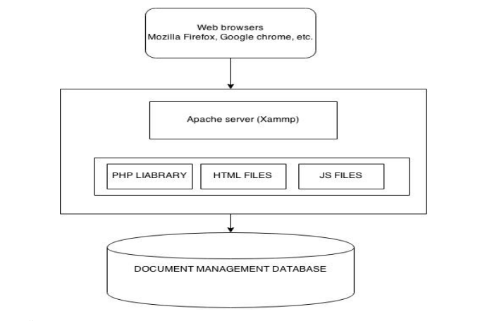

Figure 1 System architecture diagram.

### 3.7.1 Data Flow

This data flow ensures efficient management and utilization of student information throughout their academic journey. In a typical student academic advising system, the data flow involves various components and processes that interact with each other. Here is a simplified description of the data flow in a student academic advising system:

1. Data Input: The student academic advising system receives data input from various sources, such as student registration forms, attendance records, grades, and course information. This data can be entered manually by administrators or teachers or can be imported from external systems.
2. Data Storage: The input data is stored in a database or a structured storage system. The database maintains separate tables for storing student information, courses, attendance records, and other relevant data. (Wang, & Sun, (2018).
3. Data Processing: The student academic advising system processes the stored data to perform various operations. This includes validating and verifying the input data, calculating statistics and reports, generating schedules, and managing student enrollment in courses.
4. Data Retrieval: Users, including administrators, teachers, and students, can retrieve specific data from the system. They can search for student information, course details, attendance records, and generate reports based on their roles and access privileges.
5. Data Updates: The student academic advising system allows authorized users to update and modify data. Administrators can add or remove student records, update course details, and manage user accounts. Teachers can mark attendance, enter grades, and update student information.
6. Data Output: The student academic advising system generates various outputs based on user requests and system processes. These outputs can include reports, such as attendance reports, grade reports, student transcripts, and course schedules. The system can also send notifications and alerts to users regarding important events or deadlines.
7. Data Integration: The student academic advising system may also integrate with other systems or services, such as the institution’s email system or a learning management system (LMS). (Uzun, & Uzun, (2019). This integration allows for seamless data exchange and sharing between the student academic advising system and other systems.

The description provided here offers a generalized overview of the data flow in a student academic advising System.

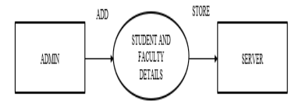

Figure 2: DFD Level 0

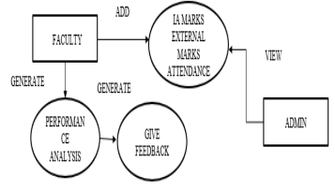

Figure 3 : DFD Level 1

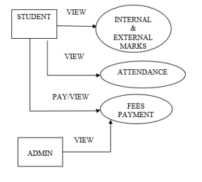

Figure 4: DFD Level 2

### 3.7.2 System Logical ER Design

The ER diagram of the student academic advising system illustrates the interactions and relationships between different objects and components within the system. It shows how these entities collaborate and communicate to achieve specific functionalities. The diagram helps visualize the flow of information and actions, facilitating a better understanding of the system’s overall structure and behavior (Rodríguez-García, Favela, and Herrera-Alcántara, 2019).

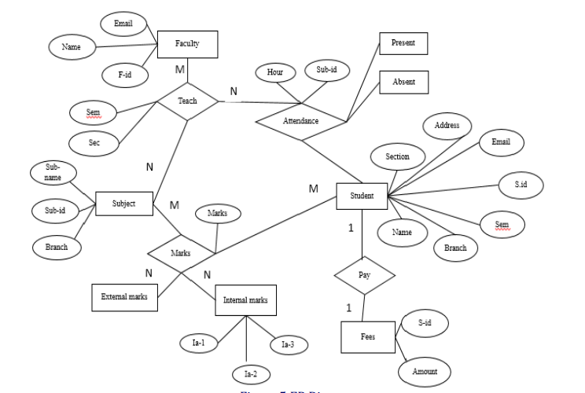

Figure 5 ER Diagram

## 3.8 Transition Phase

During the Transition phase of designing and implementing the student academic advising System for the Computer Science Students Department, the focus is on preparing the system for deployment and user acceptance. This involves final testing, comprehensive documentation, training programs, data migration (if applicable), user acceptance testing, and deployment in a production environment. The Transition phase ensures that the student academic advising system is ready for effective use by stakeholders in the department. (Park, and Yun, 2019).

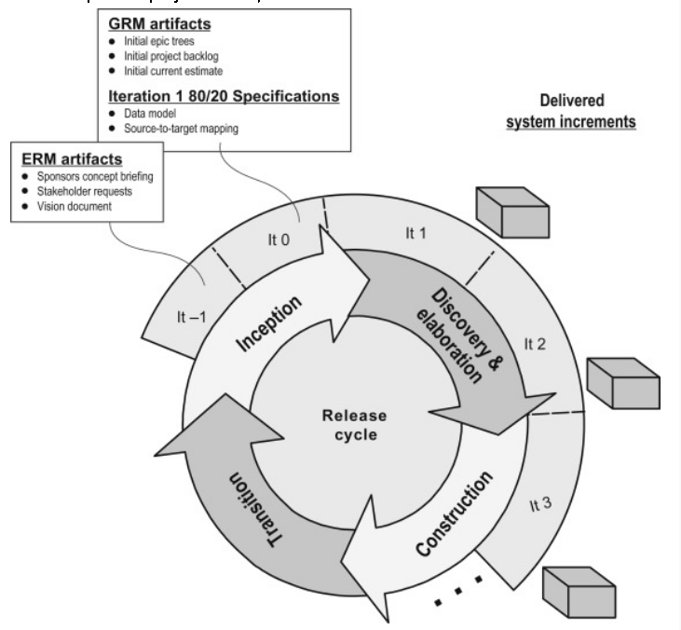

Figure 6 RUP model

## 3.9 Chapter Summary

In Chapter 3, the Rational Unified Process (RUP) model was chosen as the methodology for the project. The chapter explores the challenges, significance, and requirements analysis process associated with implementing the RUP model. The challenges discussed include the need for a skilled development team, managing project scope in iterative development, and integrating software components. The significance of RUP lies in its structured approach, adherence to industry best practices, and emphasis on collaboration and stakeholder involvement. The chapter also highlights the importance of requirements analysis in the RUP model, which involves gathering and documenting software requirements accurately to guide the development process effectively. and, an emphasis on each phase of the RUP model Overall, the adoption of RUP brings a disciplined and comprehensive framework to the project, facilitating the development of high-quality software systems.

# CHAPTER FOUR

# IMPLEMENTATION

## 4.0 Introduction

Chapter Four, delve into the implementation of a web-based student academic advising System, utilizing HTML, CSS, JavaScript, PHP, MySQL, Bootstrap, and Xampp server for deployment. This chapter focuses on the practical aspect of bringing the system to life by translating the design and requirements into functional components. It discusses the implementation details of key features such as the login page, admin dashboard, Lecturers Dashboard, student login functionality, dashboard, and operations. Additionally, it explores the deployment process using the Xampp server, ensuring a seamless setup for hosting a web-based student academic advising System locally. By the end of this chapter, it aims to present a fully functional and user-friendly system that empowers institutions and enhances the overall management of their institution’s operations.

## 4.1 Deployment Using Xampp Server

Configuration and deployment of a web-based student academic advising System using the Xampp server

1. Setting up the necessary environment for hosting the system locally
2. Database setup and connectivity
3. Web server configuration and running the application

## 4.2 Home Page

The homepage design of the student academic advising system incorporates HTML, CSS, JavaScript, PHP, MySQL, and Bootstrap. It serves as the central hub for accessing various features and functionalities. The HTML structure provides the foundation for organizing elements, while CSS enhances the visual appearance and styling. JavaScript adds interactivity, allowing for dynamic content loading and user-friendly features. PHP handles server-side processing, retrieving data from MySQL database to populate the homepage with relevant information. Bootstrap ensures a responsive and mobile-friendly layout, optimizing the user experience across different devices. The homepage highlights key components such as student Login, Student Registration, and Admin Login



Figure 4.1 Home Page Student academic advising

## 4.3 Database

The MySQL database in the student academic advising system performs various functions to efficiently manage the system. It includes tables for admin, category, problem remarks, departments, subcategories, problems, student logs, and student information. The database enables secure access and management of system administrators, categorizes advising topics, stores advisor remarks, and student problems, maintains department information, organizes advising subcategories, tracks advising sessions in the student log, and stores student details. This comprehensive database ensures effective organization and retrieval of data, enhancing the overall academic guidance and advising process for students.

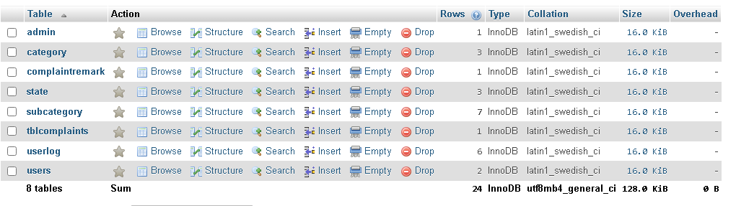

Figure 4.2 Student academic advising database table

## 4.4 Admin Login Page

The Admin Login page is created using HTML, CSS, and JavaScript to provide a secure interface. HTML includes input fields for the admin’s username and password. CSS is used for styling, while JavaScript handles form validation and authentication. Upon successful validation, admins gain access to the system’s administrative features.

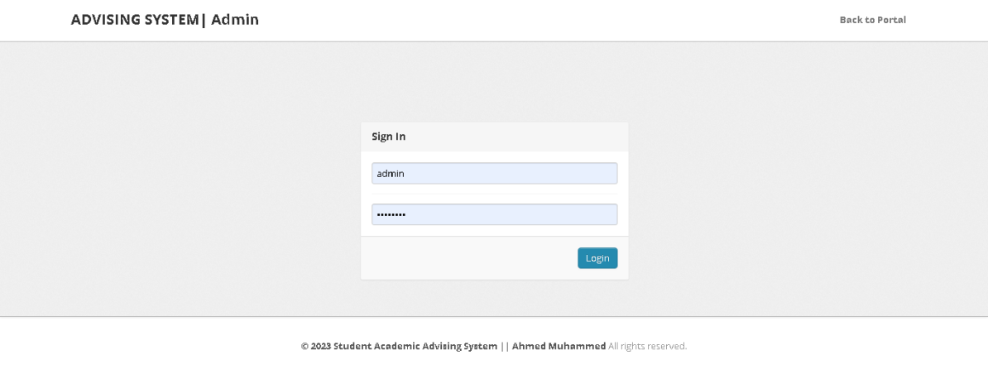

Figure 4.3 Admin login page

## 4.5 Admin Dashboard

The Admin Dashboard design utilizes HTML, CSS, JavaScript, PHP, MySQL, and Bootstrap to create a comprehensive and interactive interface. HTML and CSS are used to structure and style the elements, while JavaScript enhances functionality and interactivity. PHP and MySQL handle server-side processing and database operations, providing the admin dashboard with dynamic content and data management capabilities.

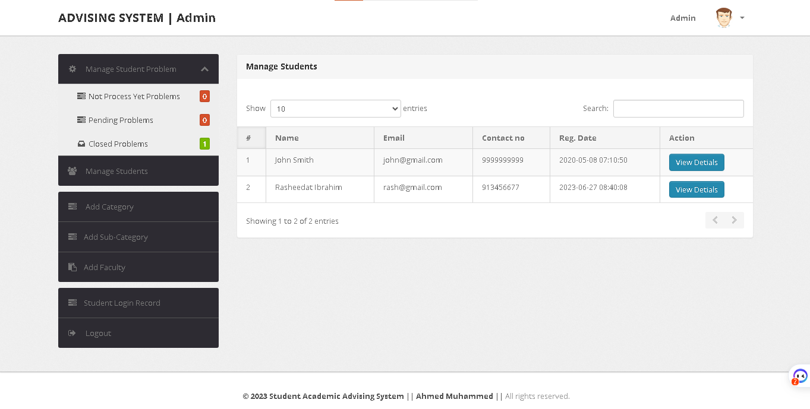

Figure 4.4 Admin Dashboard

Admin dashboard in the academic advising student system provides essential functionalities for managing student problems, analyzing, and advising students, maintaining student records, categorizing problems, assigning faculty, and accessing student details. It allows administrators to efficiently handle student issues, provide guidance, and track academic progress. Implemented with PHP, MySQL, Bootstrap, CSS, JavaScript, and HTML, the admin dashboard streamlines the problem-resolution process, enhances student support, and facilitates effective academic advising.

## 4.6 Student Registrations/ Login

The student registration/Login page is created using HTML, CSS, and JavaScript to provide a secure interface. HTML includes input fields for the student’s username and password, CSS is used for styling, while JavaScript handles form validation and authentication. Upon successful validation, the Student gains access to the system’s administrative features.



Figure 4.5 Student login page

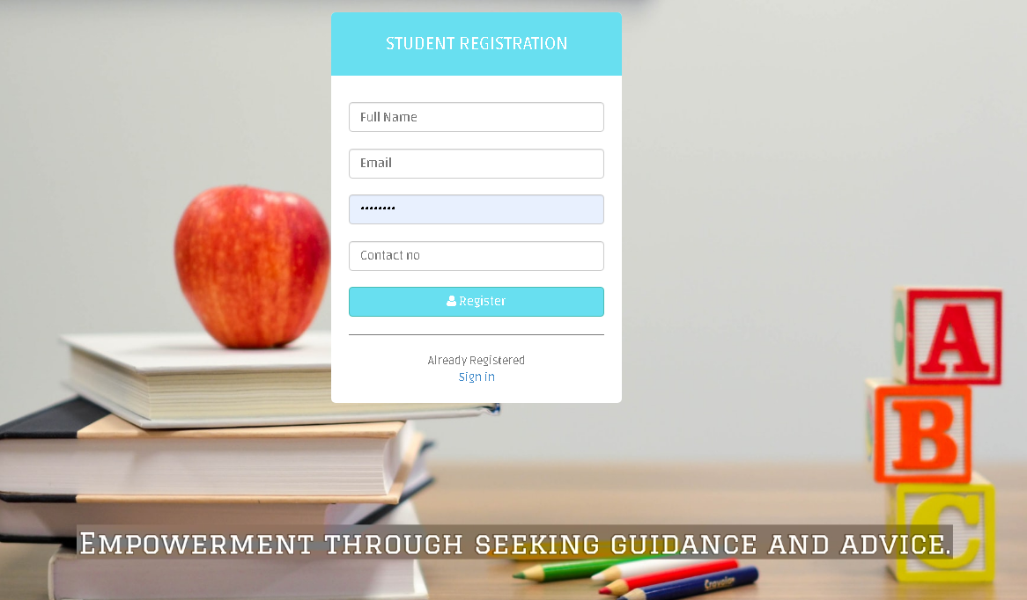

Figure 4.6 Student Registration Form page

## 4.7 Student Dashboard

The student dashboard in the academic advising student system provides several key functions. It allows students to manage their account settings, update their profile information, and change their passwords for enhanced security. Additionally, students can log problems to seek advice and access their problem history for reference and tracking. Implemented with PHP, MySQL, JavaScript, HTML, and CSS, the student dashboard offers a user-friendly interface for students to efficiently navigate and utilize these functions in the academic advising system.

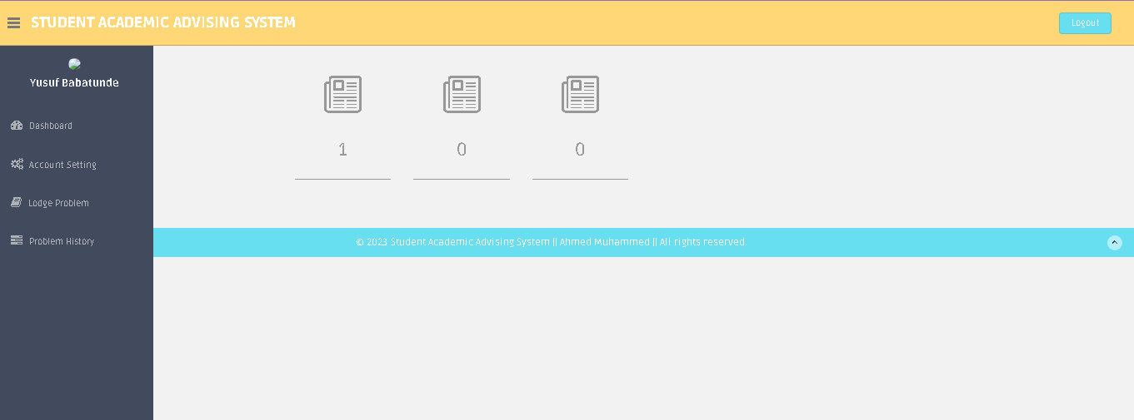

Figure 4.7 Student Dashboard

## 4.8 Testing And Results

Testing plays a crucial role in ensuring the reliability, functionality, and performance of web-based student academic advising Systems. This project adopted a comprehensive approach to testing the software. As shown below in the table.

Table 1. System Evaluation Rating of the System Quality

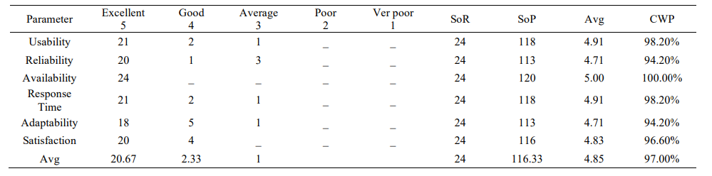

Table 2. System Evaluation Rating of the System Use.

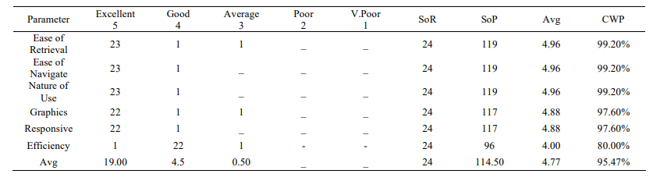

Where; SoR, SoP, Avg, and CWP refer to the Sum of response, Sum of Parameters, and Average and Cumulative Weighted percentages respectively.

In conclusion, the web-based student academic advising System's testing phase successfully validated the system's functionality, usability, and performance. The results obtained through unit testing, integration testing, and user acceptance testing provided confidence in the reliability and effectiveness of the system. Any identified issues were addressed, ensuring a robust and efficient system for institutions and students to streamline their operations and enhance their experience.

## 4.9 Chapter Summary

Chapter Four covers the implementation of various pages and functionalities for web-based student academic advising Systems. It includes the design and implementation of the login page, admin dashboard, student management page, student login functionality, dashboard, and operations using a combination of HTML, CSS, JavaScript, PHP, MySQL, and Bootstrap. Additionally, the chapter addresses the deployment of the system using the Xampp server, ensuring the proper setup and configuration for local hosting.

# CHAPTER FIVE

# SUMMARY, CONCLUSION, AND RECOMMENDATIONS

## 5.0 Summary

In summary, this study provides an overview of the web-based student academic advising system, which aims to streamline and enhance the academic advising process in educational institutions. discussed the key features and functionalities of the system, including student registration, course selection, advisor assignment, scheduling appointments, tracking academic progress, and generating reports. The system is designed to improve efficiency, communication, and decision-making in the academic advising process. it utilized web technologies such as HTML, CSS, JavaScript, PHP, and MySQL to develop a user-friendly and interactive interface for students and advisors.

## 5.1 Conclusion

The web-based student academic advising system provides a comprehensive solution for educational institutions to optimize their advising services. By leveraging modern web technologies, we have created a system that simplifies the advising process and empowers both students and advisors with the necessary tools to make informed decisions. The system promotes efficient scheduling, enhances communication between students and advisors, and improves academic planning and progress tracking. It facilitates a streamlined and personalized advising experience, ultimately leading to better student outcomes and satisfaction.

## 5.2 Recommendation

Based on our analysis and evaluation of the web-based student academic advising system, we recommend the following:

1. Implementation: Proceed with the implementation of the system using the technologies outlined in this document. The design and functionality presented provide a strong foundation for the development process. Consider implementing the system in an agile manner, allowing for iterative improvements based on user feedback and evolving institutional needs.
2. User Testing and Feedback: Conduct extensive user testing with students, advisors, and administrative staff to gather feedback on the system's usability, functionality, and overall user experience. Incorporate this feedback into the development process to ensure that the system aligns with the needs and expectations of its users.
3. Integration with Existing Systems: Assess the possibility of integrating the web-based student academic advising system with other existing systems within the institution, such as student information systems or learning management systems. Integration can improve data exchange, automate processes, and provide a unified experience for users.
4. Training and Support: Develop a comprehensive training program and support resources for students, advisors, and administrative staff to ensure they are proficient in using the system. Provide ongoing technical support and regularly update the system to address any issues or incorporate new features.
5. Security and Privacy: Prioritize the security and privacy of student and advisor data within the system. Implement robust authentication mechanisms, secure data storage, and access controls to protect sensitive information. Comply with relevant data protection regulations and regularly audit the system for vulnerabilities.

By following these recommendations, educational institutions can successfully implement the web-based student academic advising system and improve the efficiency and effectiveness of their advising services. The system will enable better student-advisor collaboration, enhance academic planning, and contribute to overall student success.

# REFERENCE

Alvarez, D., & Toledo, P. (2018). Web-Based Advising System for Students in Higher Education. In Proceedings of the 10th International Conference on Computer Supported Education (pp. 334-341). Springer.

Chen, J., Zhang, L., Chen, Y., & Huang, X. (2018). Design and Implementation of a Web-Based Academic Advising System. In 2018 IEEE 6th International Conference on Future Internet of Things and Cloud (FiCloud) (pp. 297-302). IEEE.

Gao, Y., & Hu, Q. (2019). Development of a Web-Based Student Advising System with Data Mining and Machine Learning Techniques. Journal of Computing in Higher Education, 31(1), 184-199.

Kitsantas, A., & Dabbagh, N. (2016). Mobile Academic Advising: Development and Evaluation of a Mobile Application. The Internet and Higher Education, 30, 1-10.

Kim, Y., & Lee, J. (2018). Design and Usability Evaluation of a Web-Based Advising System for College Students. Journal of Educational Technology & Society, 21(2), 223-235.

Liu, Z., & Qiu, Y. (2019). Development of a Web-Based Advising System Using PHP and MySQL. In 2019 IEEE 3rd Advanced Information Management, Communicates, Electronic and Automation Control Conference (IMCEC) (pp. 964-968). IEEE.

Lu, M., & Wu, S. (2018). Design and Implementation of an Intelligent Web-Based Academic Advising System. In 2018 International Conference on Educational and Information Technology (ICEIT) (pp. 190-194). IEEE.

Mallory, M. (2016). The Web-Based Academic Advising System: Development, Implementation, and Impact. Journal of Academic Advising, 10(2), 51-63.

Marpaung, E. D. (2018). Development of Web-Based Academic Advising System Using PHP, CodeIgniter, and MySQL. In 2018 International Conference on Information Management and Technology (ICIMTech) (pp. 163-167). IEEE.

Mays, G. L. (2018). Development of a Web-Based Advising System for Student Success. Journal of College Student Retention: Research, Theory & Practice, 20(4), 457-474.

Nofrianto, A., Kurniawan, F., Hidayat, S., & Prasetyo, Y. B. (2017). Web-Based Academic Advising System Using PHP and MySQL. In 2017 International Conference on Information Management and Technology (ICIMTech) (pp. 220-224). IEEE.

Park, S., & Yun, J. (2019). Design and Implementation of an Intelligent Academic Advising System Using Ontology-Based Knowledge Engineering. Sustainability, 11(8), 2351.

Rodríguez-García, A., Favela, J., & Herrera-Alcántara, O. (2019). A Mobile and Web-Based Recommender System for Academic Advising. Interactive Learning Environments, 27(6), 833-850.

Sridharan, A., & Gopalakrishnan, S. (2019). Development of a Web-Based Academic Advising System with Student Performance Prediction using Data Mining Techniques. In 2019 5th International Conference on Advanced Computing & Communication Systems (ICACCS) (pp. 1-6). IEEE.

Tang, X., Fu, Y., & Yu, T. (2020). Development of an Academic Advising System Based on Blockchain and Smart Contracts. Future Generation Computer Systems, 112, 22-32.

Tapanainen, T., & Kailanto, M. (2017). Students’ Expectations of Academic Advising in a Web-Based Environment. Computers in Human Behavior, 72, 578-585.

Uzun, B., & Uzun, N. (2019). Development of a Web-Based Academic Advising System. In 2019 International Conference on Computer Science and Engineering (UBMK) (pp. 738-741). IEEE.

Wang, H., Guo, W., & Tang, S. (2018). Design and Implementation of a Web-Based Advising System for College Students. In 2018 International Conference on Intelligent Computing, Instrumentation and Control Technologies (ICICICT) (pp. 1-5). IEEE.

Wang, X., & Sun, S. (2018). Design and Implementation of a Web-Based Academic Advising System Based on Big Data. In 2018 15th International Computer Conference on Wavelet Active Media Technology and Information Processing (ICCWAMTIP) (pp. 34-38). IEEE.

Zhou, M., Liu, Z., & Chen, Y. (2020). Development of a Web-Based Advising System for College Students. In 2020 4th International Conference on Mathematics, Artificial Intelligence and Physics (ICMAIP) (pp. 227-231). IEEE.

# APPENDIX

